Bert Sutcliffe
Parnell Cricket Clubs’s Prodigy - “The Last Everyday Hero”

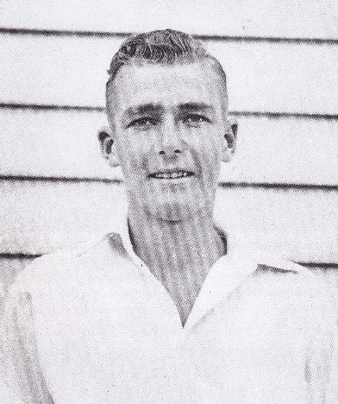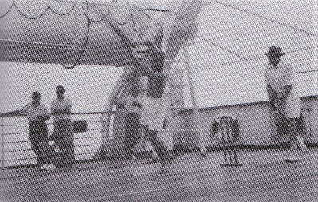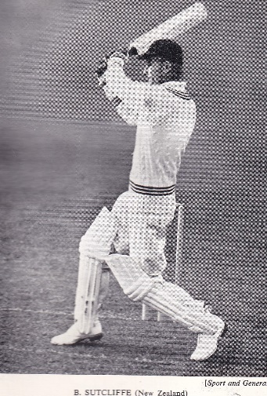
Parnell Days
1941 – Bert at 18 1949 – batting on deck en route to England Test batsman & Wisden Cricketer of the Year

THE PARNELL CC ERA: Much has been written about Bert, quite probably New Zealand’s greatest ever batsman. Wisden detailed his exploits when they named him one of their 5 Cricketers of the Year for 1949 and way back, and very modestly, Bert wrote his own autobiography.

In 2010 Richard Boock wrote his biography of Bert – “the Last Everyday Hero – the Bert Sutcliffe Story”. Published by Longacre, the book was launched at our, Parnell CC’s Clubroom with Norma, Bert’s widow and son David present.
An excellent resume of Bert’s life and outstanding achievements as a cricketer at provincial and international levels and a must read for any young sportsman aspiring to reach the top.

Bert did exceedingly well for Takapuna Grammar, selected for the 1st XI in his last term as a 3rd Former, captain from 1939 and then Head Prefect. Richard Boock wrote “no one, before or since has dominated Auckland secondary school cricket to the same extent”. And that includes Ross Morgan and Martin Crowe who were prolific scorers in their teens.

The Last Everyday Hero – in the 1939/40 season 16 year old Bert was selected for the Auckland team for the National Under 19 Brabin Cup. Played in Canterbury, Auckland won the Tournament and Bert played outstandingly, hit a century against Canterbury, and was selected for the NZ Colts team to tour Australia. However, WW 2 had broken out and the tour didn’t eventuate. He did, however, play for Auckland Schools against Sir Julian Cahn’s touring XI which included Stewie Dempster and Bill Merritt.

That summer Bert made his debut for Parnell but only played one game for the Parnell Senior XI scoring 1 and 7 not out. But Bert’s talent was obvious and whilst he was living with his family at Tor Bay, Auckland Cricket Association had encouraged him to come under the mentorship of Parnell’s Merv Wallace, Giff Vivian and Paul Whitelaw. To this end Jack Forsman would cross the harbour on the vehicular ferry to collect Bert from Takapuna Grammar and bring him to Parnell’s practice at Auckland Domain.

The next season, 1940/41, Bert hit his first ton for Parnell – 122, vs Ponsonby-Balmoral – a superb knock but he was admonished by his skipper and mentor, Merv Wallace, for giving his wicket away – a lesson well remembered and appreciated! In his 6 games for Parnell, this 17 year old scored 262 runs at 43.67.

Selection for Auckland’s Plunket Shield XI came in 1941/42 when he was 18. Just one game and he scored 11 but Bert was able to play 10 games for Parnell – top score was 96 and he averaged 30. Not the most auspicious start but, whilst he didn’t play for Auckland – the Plunket Shield was discontinued 1940-45 due to WW 2 – Bert played 12 games for Parnell, hit another ton – 109, and totalled 778 at 111.29. WW 2 was raging - a time when Hedley Verity , the great England left arm spinner, and New Zealand reps, “Sonny” Maloney and Bill Carson, had died in action or of wounds.

Bert applied for military training at Duntroon in Australia but wasn’t accepted, a considerable disappointment. He was finally enlisted at 21 and was on a ship enroute to Cairo when the War in Europe ended. Meantime he had turned out for Parnell quite regularly in the 2 previous seasons and for Auckland for 1st Class fixtures even though no Plunket Shield. His maiden century came in his just his second game – 146 vs Wellington. 86 was his best for Auckland the next season but it was in North Africa with the Army that his talents really blossomed.

Whilst fighting had ceased there were still NZ troops in the deserts of North Africa and many Kiwi cricketers, along with 1st Class even Test players, from England, Australia and South Africa, were taking part in sternly contested games at Alamein and Maadi Camps. Playing in intense heat on coconut matting pitches Bert batted exceedingly well and averaged close to 60 – he relished the competition. Then to Japan with J Force for 3 months before returning to home to New Zealand in July 1946. It was in Japan a fellow soldier taught Bert to play the guitar and awakened a love of music and teaching himself to play the piano – a natural, as future touring teams will attest!
1946/47 Season – back home, with fiancée to be, Norma Love, waiting, Bert turned out for Parnell in 4 games pre Christmas hitting one ton. Then for Auckland in the Plunket Shield, he hit 2 centuries. He had started teaching at Avondale Intermediate but his application to Otago University’s Phys. Ed school had been accepted. Plunket Shield games behind him, Bert arrived in Dunedin in time to be selected for the Otago vs MCC game. The MCC/England, lead by the great Wally Hammond, had lost the Ashes series across the Tasman, beat Wellington by 214 runs and then met Otago and Bert.

This was the moment – Bert, asked by skipper Walter Hadlee, to open for the first time, hit 197 and 58. Set 218 to win in 2 hours the MCC, the game ended with the visitors 9 down and 2 short of victory – an incredible game!
Bert’s Test debut came in the next game – vs England, NZ batted first with Bert opening with Hadlee and they put on 133. Bert was caught behind by Evans off Bedser for 58, Hadlee hit 116 and declared at 345/9. For England Hammond scored 79 (his last innings) and made a sporting declaration at 245/7. Sadly, rain came – the 3rd day was washed out and whilst an extra day was agreed, rain prevented any further play.

1947/48 Season – Bert remained in Dunedin and turned out for Otago and the North Island. No games for either Parnell or Auckland but the momentum had started – Bert’s first double century, 208* for North Island vs South Island, 911 runs in all at 101.22.

1948/49 Season – a crucial time with selection needing to be made for the ’49 England tour. The Fijians were also touring and Bert was back in Auckland playing once again for Parnell and Auckland. Again though, Bert was only able to play 4 games for the Club but his 179 was his highest ever for the Club. For Auckland, Bert also excelled - 141 and 135 vs Canterbury [with DD Taylor, for the 1st wicket, partnerships of 220 and 286 – a World Record that still stands in 2023] and, in one of the trials, 140 for a New Zealand XI vs The Rest. Then, along with fellow Parnell teammates Merv Wallace and Johnny Hayes and baggageman/scorer Warwick Watts, off with the New Zealand team to England. Geoff Rabone was to join Parnell when he moved to Auckland following the Tour.

The Forty Niners – they embarked on the Dominion Monarch on 26 February 1949 bound for England, not to return until the Team disembarked in Wellington from the Rangitata on 26 October.

The cricket in England was exceptional. First, Merv Wallace almost scored 1,000 in May then Bert and Martin Donnelly took over – Bert hit 7 centuries, Martin 5. Bert’s 2,627 runs remains 2nd only to Don Bradman for a touring batsman. The 3 Tests were all drawn – not surprising as they were only of 3 days. Donnelly retired at the end of the tour and was honoured by Wisden. And the Almanack accorded Bert the honour of selecting him as one of their five Cricketers of the Year.

So the Parnell CC era ended - on return from England , Bert returned to Dunedin to be employed by Otago Cricket as their coach. And there he remained - lost to Parnell but scoring very heavily for Otago and in the very few Tests played over the next 3-4 years. But he remained a Parnell member throughout his life even though, after a stint with Northern Districts and, when back in Auckland, he played for the Cricket Society and becoming its President.

After 1949 and through to 1953, Tests were few and far between, nothing against Australia and no tour overseas until South Africa in 1953/54. But with colossal scoring in the Plunket Shield – 2 treble centuries and a Test 100 vs England, noted Australian author Ray Robinson considered his record comparable to that of Don Bradman. In fact he scored 50+ in each of his first 5 Tests – a record not equalled for many years and only beaten in 2023.

Bert did make two further appearances for Parnell – in Jubilee games. First at Easter 1959 when Parnell CC played an Auckland XI at Hobson Park. Auckland 381/9 dec. Tom Hambrook 109 Parnell 382/4 Geoff Rabone 145, Bert Sutcliffe 73. And secondly, in March 1984 in a social game but, always, Bert considered himself a Parnell man!

BERT’S BATTING STATS FOR THE PARNELL ERA:
 | Parnell: |  |  |  |  |  | First Class:
 | In | NO | HS | Agg | Ave | 100s | In | NO | HS |  | Agg | Ave | 100s
1939/40 | 2 | 1 | 7 | 8 | 8.00
1940/41 | 6 | 0 | 122 | 262 | 43.67 | 1
1941/42 | 10 | 2 | 96 | 241 | 30.13 |  | 1 | 0 | 11 |  | 11 | 11
1942/43 | 12 | 5 | 108 | 779 | 111.29 | 1
1943/44 | 14 | 0 | 129 | 544 | 38.86 | 1 | 5 | 0 | 146 |  | 163 | 32.6 | 1
1944/45 | 6 | 4 | 156 | 368 | 184.00 | 1 | 7 | 0 | 86 |  | 246 | 35.14

1945/46
1946/47 | 4 | 1 | 56 | 114 | 38.00 |  | 8 | 1 | 197 |  | 722 | 103.14 | 3
1947/48 |  |  |  |  |  |  | 10 | 1 | 208 | * | 911 | 101.22 | 4
1948/49 | 4 | 1 | 179 | 359 | 119.67 | 1 | 6 | 0 | 141 |  | 511 | 85.16 | 3
1949 UK |  |  |  |  |  |  | 49 | 5 | 243 |  | 2627 | 59.7 | 7
1949/50 |  |  |  |  |  |  | 9 | 0 | 355 |  | 698 | 77.55 | 2
Plus some of his most memorable innings over his whole career:
- Test centuries: 101 vs England 3rd Test 1949
116 vs England 1st Test 1950/51
137* vs India 1st Test 1955/56
240* vs India 3rd Test 1955/56
151* vs India 2nd Test 1964/65
- Double centuries 208* North Island vs South Island 1948/49
243 NZ vs Essex 1949
275 Otago vs Auckland 1950/51
230* NZ vs India 3rd Test 1955/56
264 Otago vs Centra District 1959/60
201 Otago vs Northern Districts 1960/61
- Treble centuries 355 Otago vs Auckland 1949/50
385 Otago vs Canterbury 1952/53
[highest ever by left hander till Brian Lara’s 501* in 1994]

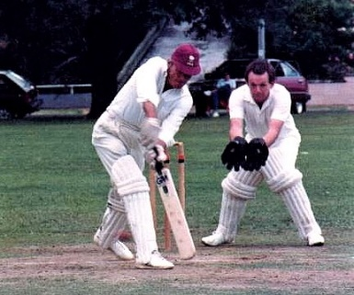
1984 - Last time in a Parnell cap – Bert batting at Orakei Domain

