Wisden - 2002 - Obituary
Bert Sutcliffe 17 November 1923 – 20 April 2001

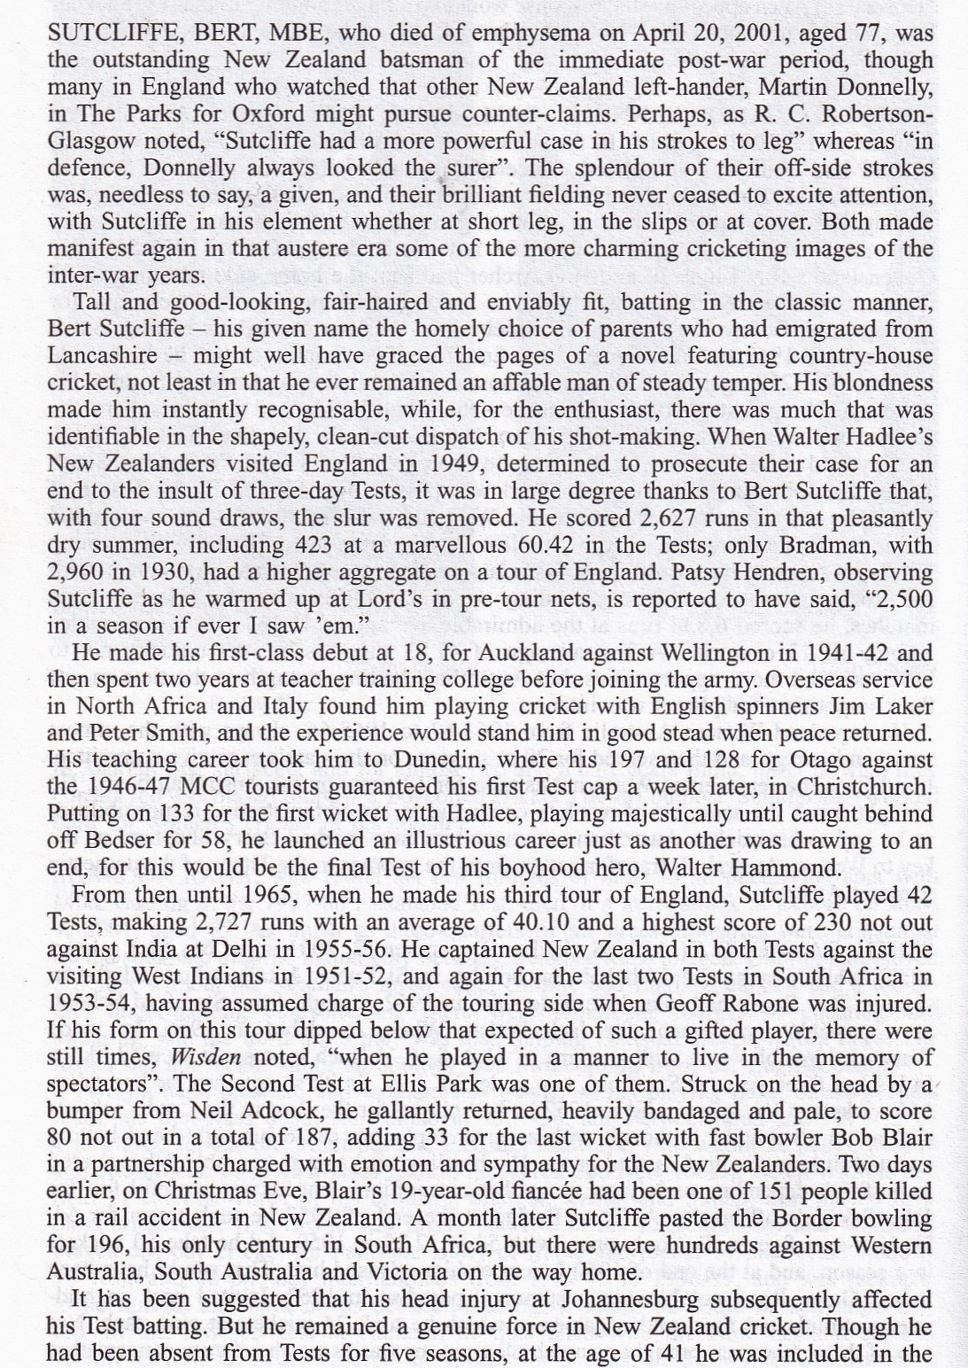

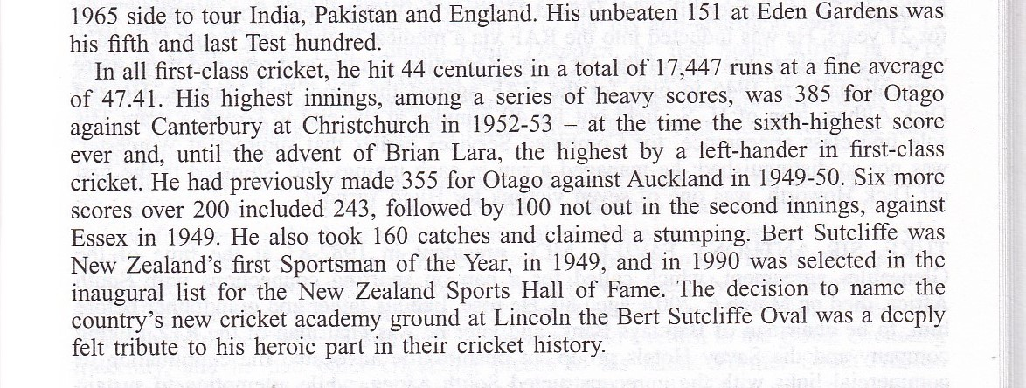

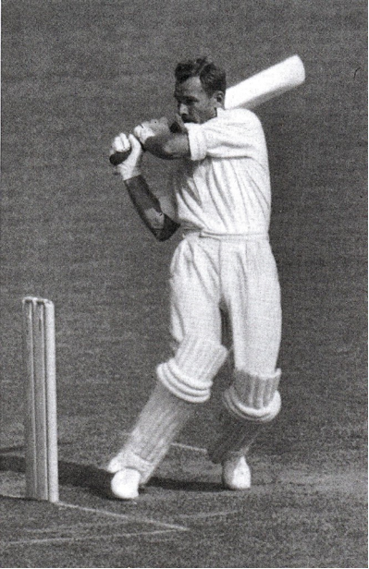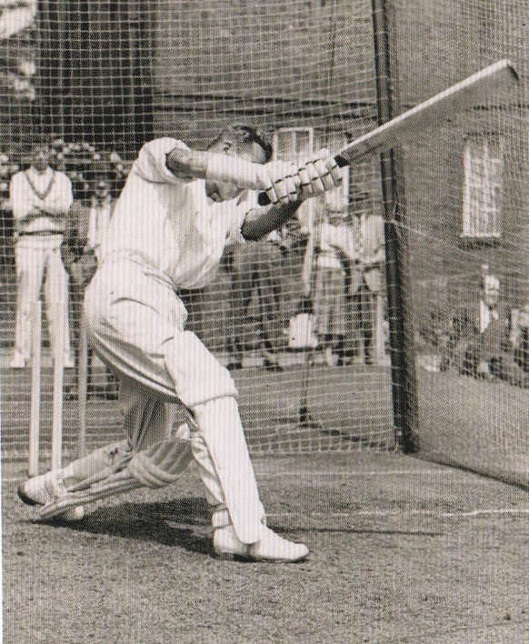
An exceedingly elegant batsman – here with a characteristic pull and, right, cover driving in the Lord’s nets in 1958

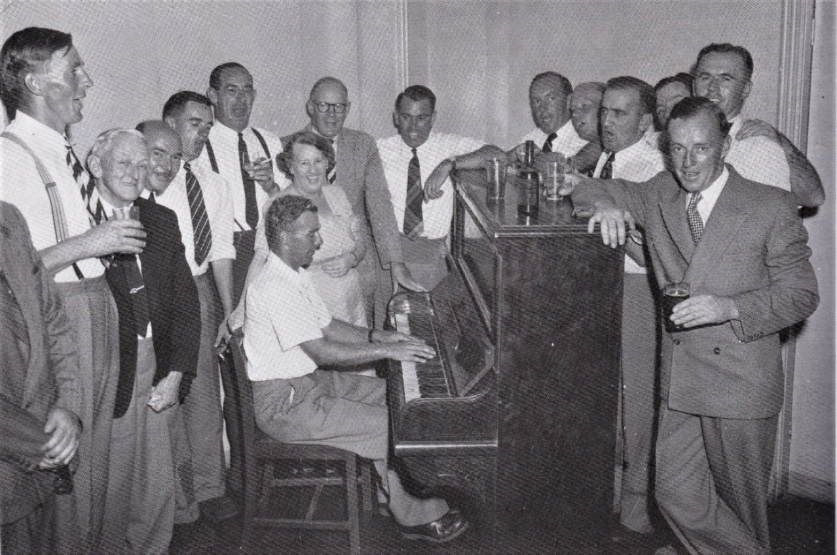
Bert on the Piano – a reunion of cricketing touring mates.
Important social times when away from home for up to 6 months as was the case in 1949!

Postscript – 2nd Test, South Africa vs New Zealand, Ellis Park, Johannesburg, 24-29 December 1953: 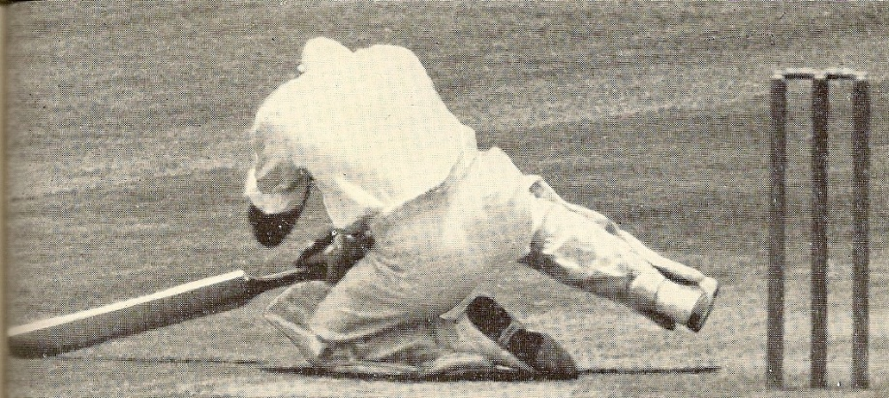 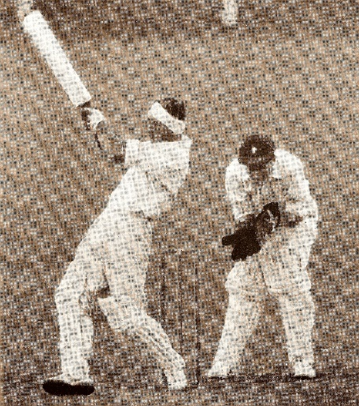
Bert, felled by a ball from Neil Adcock, back from hospital hit 80* including 7 sixes

Whilst Bert was to go on to hit centuries against each of the 3 Australian states on his way home from South Africa plus 230* against India the following year and, 11 years later, 151* also against India, it was that fateful day at Ellis Park that really marked Bert’s later career. Boxing Day 1953 – the Test was played at Ellis Park, the rugby field. Wanderers, the old ground in Rissik Street in the City, was demolished for the railway station and New Wanderers at Ilovo was not yet ready.
South Africa won the toss and batted and all out early on Day 2., Boxing Day, for 271. Bob Blair, our fast bowler didn’t take the field on the 2nd Day – news had come that his 19 year old fiancé had died in the terrible Tangiwai Disaster. NZ started badly, Neil Adcock, tall rangy and very fast, had the ball standing off a length and Dave Ironside getting swing and lift, were nasty.
I leave it to the Cricket Almanack of New Zealand to describe the scene:
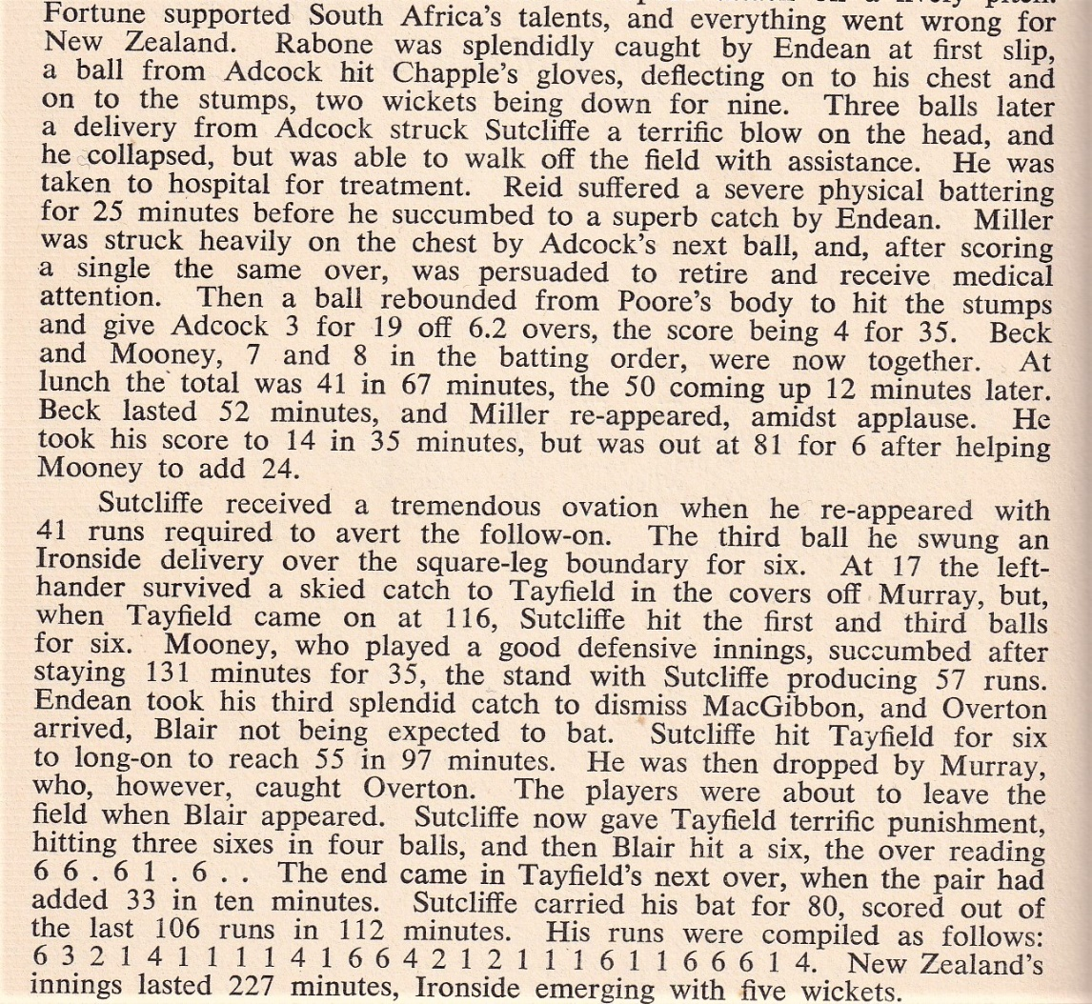
In the recent Ashes series we saw Ben Stokes play a very similar innings – remarkable hitting that transformed Test cricket – but nothing can compare to the drama and pathos of that Boxing Day at Ellis Park with the injured Bert Sutcliffe and bereft Bob Blair at the crease!

